Automower® Winter Service Plan
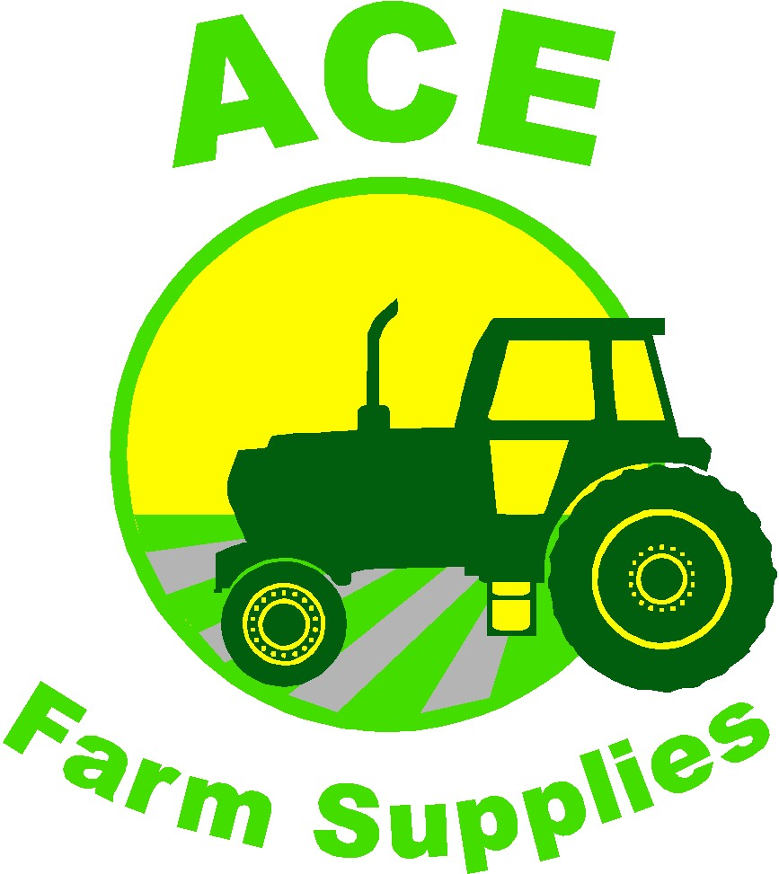

After a tough working season keeping your lawn flawless, your Automower® will be ready for some TLC.
A round of service and maintenance will make sure that your Automower® continues to work perfectly for the next season.
Bronze Service  Bring your automower® to us.  - Cleaning  - Full system diagnostic test, to include battery function test and safety function test  - Software update  - Replace blades  - Inspection of gaiters, bellows, cables, ventilation filter and check fastenings.  - Fully charge battery  £80 + VAT  (Third Year Service £110 + VAT) | Silver Service  We will collect and return your automower® with the charging station  - Cleaning  - Full system diagnostic test, to include battery function test and safety function test  - Software update  - Replace blades  - Inspection of gaiters, bellows, cables, ventilation filter and check fastenings.  - Fully charge battery  - Collection and return  £100 + VAT  (Third Year Service £130 + VAT) | Gold Service  We will collect your automower® with the charging station, store it over winter and return it to you next spring.  - Cleaning  - Full system diagnostic test, to include battery function test and safety function test  - Software update  - Replace blades  - Inspection of gaiters, bellows, cables, ventilation filter and check fastenings.  - Fully charge battery  - Collection, winter storage and return in the spring.  £130 + VAT  (Third Year Service £160 + VAT) | Platinum Service  This plan covers all servicing for the first 3 years.  Includes collecting your automower® with the charging station, storing over winter and returning each spring.  - Cleaning  - Full system diagnostic test, to include battery function test and safety function test  - Software update  - Replace blades  - Inspection of gaiters, bellows, cables, ventilation filter and check fastenings.  - Fully charge battery  - 3rd year service replacements – bellows, ventilation filter, sealing strips.  - Collection, winter storage and return in the spring.  £336 + Vat
Cleaning
We will dismantle the machine to ensure that all parts are moving correctly. We will clean the mud and grass off of the mower to ensure that operation of the mower isn’t restricted and to ensure cutting is kept at the expected high-quality level.

Full System Diagnostic test
Using Husqvarna’s Autocheck computer software we will test all components of the Automower®, including motors, batteries and sensors.
All of the Automower®’s functions are simulated in the workshop and results are evaluated.

Software update
The Automower® will be updated with the latest software provided by Husqvarna.

Replacement of blades
The skid plate is removed and cleaned, and the blades and screws are replaced.

Inspection of working components
The gaiters, bellows, seals, bearings and ventilation filter will all be inspected and tested. All electrical connections and cables will be checked for deterioration.

Third year service
Certain components are required to be replaced every 3 years; on the third service the sealing strips, ventilation filter and bellows will be replaced as per Husqvarna recommendations.

